**Assignment 1:**

Name Khlod Mohamed Ali

ID: 5695

### Part 1: Co-Occurrence

### 

### Part 2: Prediction-Based Word Vectors

### Synonyms & Antonyms:

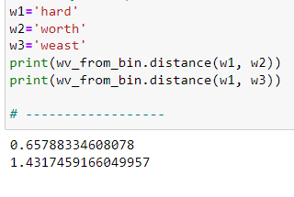

It is easy to find the relation between synonyms in word2vec but its hard to know the antonyms as word2vec does not really depend on the meaning of the words. It is based on the presence of words in the same context and around similar words.

### Finding Analogies

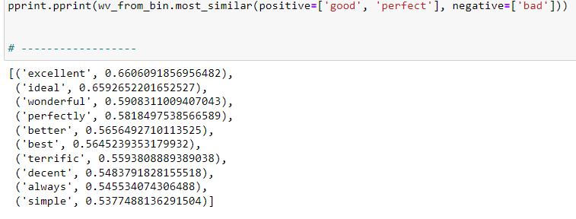

It is not easy to find analogies for the same reason.